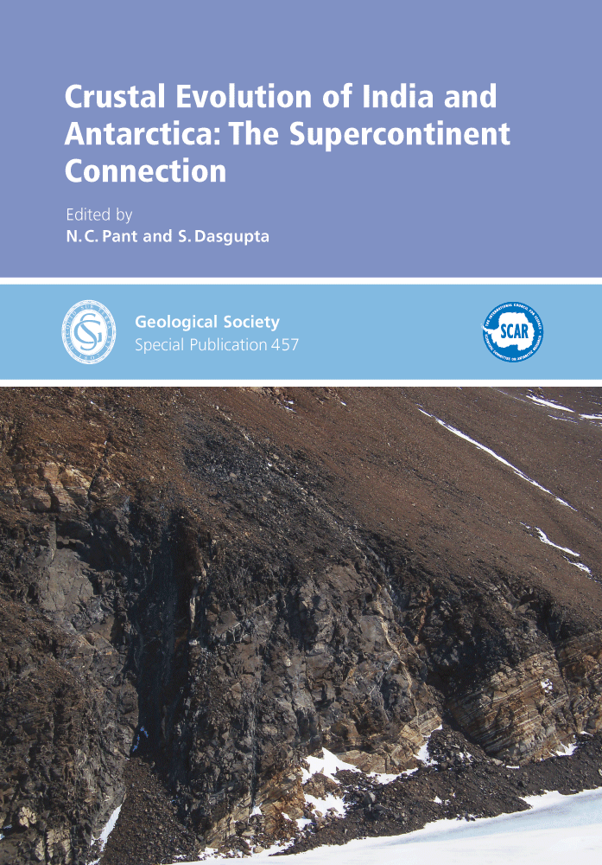

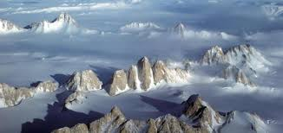
Geologists have found evidence supporting the hypothesis that Indian subcontinent was part of Antarctica a billion years ago but were separated and re-united several times due to tectonic (mechanical)movement of plates before the evolution of mankind.
“It is for the first time that we have been able to prove the hypothesis that the continent of Antarctica and subcontinent India were once a single large continent that broke apart about 1.5 billion years ago,” IIT Kharagpur geologist Dewashish Upadhyay, who led the research .

Researchers say the two continents separated many times and a new ocean was formed where the old ocean had been.

India and Antarctica then got separated by an ocean.
Their research, which was recently published in international journal Elsevier, shows the two continents separated once more and a new ocean was formed where the old ocean had been. “Then the movement of the continents reversed again and there was yet another collision around 600 million years ago which created another mountain range that is preserved in the Eastern Ghats all the way to southern India and Sri Lanka and even Madagascar, which was once part of the Indian subcontinent,” Professor Klaus Mezger of the Department of Geological Sciences at the University of Bern, Switzerland, said.

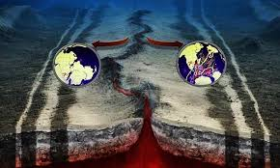
GONDWANA SEEN UNDER THE INDIAN OCEAN

GONDWANA HOSTING A HUGE VARIETY OF FLORA AND FAUNA.

